**­­NAME: R S Madhavan**

**REG NO: 19BCE7029**

**LAB: CSE4002 Mobile Application Development LAB**

1.Design an App using custom Gridview to sell the products. It should display the picture, product name, product description and cost. Take 2 pages of any real APP in your mobile First page should contain grid view.

**MainActivity.java**

package com.example.gridview;  
// add implementation 'androidx.gridlayout:gridlayout:1.0.0' to build gradle file  
import androidx.appcompat.app.AppCompatActivity;  
  
import android.content.Intent;  
import android.os.Bundle;  
import android.view.View;  
import android.widget.AdapterView;  
import android.widget.GridView;  
import android.widget.Toast;  
  
public class MainActivity extends AppCompatActivity {  
 GridView gridView;  
 String [] product_name = {"EYEBOGLER","Yellow Chimes","Yellow Chimes","FASHION GALLERY","Sanskar Fashion","CREATURE","ARZONAI","Handcuffs"};  
 String [] product_description = {"Regular Men's Cotton Designer T-Shirt (EB1T67)","High Polished Stainless Steel Kadaa Bracelets for Men Boys","Leather Base Metal and Wrist Bracelet for Unisex- Adult & Child",  
 "Men's Regular Fit T-Shirt","Mens' Shirts, Bsnded Collar Half Sleeves Shirts for Men","Men's Ankle Length Formal/Casual Socks (Multicolour; Free Size","Round Metal Fashion Retro Vintage Shield Shades Steampunk Unisex",  
 "Unisex Cap Quick Drying Sun Hat UV Protection Sports Cap"};  
 String [] product_price = {"₹430","₹381","₹249","₹449","₹559","₹214","₹399","₹474"};  
 int [] product_image = {R.drawable.*one*,R.drawable.*two*,R.drawable.*three*,R.drawable.*four*,R.drawable.*five*,R.drawable.*six*,R.drawable.*seven*,R.drawable.*eight*};  
 int [][] gallery = {{R.drawable.*one*,R.drawable.*one_two*},{R.drawable.*two*,R.drawable.*two_two*,R.drawable.*two_three*,R.drawable.*two_four*,R.drawable.*two_five*},  
 {R.drawable.*three*,R.drawable.*three_two*,R.drawable.*two_three*,R.drawable.*three_four*,R.drawable.*three_five*},{R.drawable.*four*,R.drawable.*four_two*},  
 {R.drawable.*five*,R.drawable.*five_two*},{R.drawable.*six*,R.drawable.*six_two*,R.drawable.*six_three*,R.drawable.*six_four*,R.drawable.*six_five*,R.drawable.*six_six*,  
 R.drawable.*six_seven*},{R.drawable.*seven*,R.drawable.*seven_two*,R.drawable.*seven_three*,R.drawable.*seven_four*,R.drawable.*seven_five*,R.drawable.*seven_six*,  
 R.drawable.*seven_seven*},{R.drawable.*eight*,R.drawable.*eight_two*,R.drawable.*eight_three*,R.drawable.*eight_four*,R.drawable.*eight_five*}};  
 @Override  
 protected void onCreate(Bundle savedInstanceState) {  
 super.onCreate(savedInstanceState);  
 setContentView(R.layout.*activity_main*);  
 gridView = findViewById(R.id.*grid_view*);  
  
 MainAdapter adapter = new MainAdapter(MainActivity.this,product_name,product_image,product_description,product_price);  
 gridView.setAdapter(adapter);  
  
 gridView.setOnItemClickListener(new AdapterView.OnItemClickListener() {  
 @Override  
 public void onItemClick(AdapterView<?> parent, View view, int position, long id) {  
 Toast.*makeText*(getApplicationContext(),"You Clicked "+product_name[position],Toast.*LENGTH_LONG*).show();  
 Intent intent = new Intent(MainActivity.this,ImageView.class);  
 intent.putExtra("image",gallery[position]);  
 startActivity(intent);  
 }  
 });  
 }  
}

**Activity_main.xml**

<?xml version="1.0" encoding="utf-8"?>  
<androidx.constraintlayout.widget.ConstraintLayout xmlns:android="http://schemas.android.com/apk/res/android"  
 xmlns:app="http://schemas.android.com/apk/res-auto"  
 xmlns:tools="http://schemas.android.com/tools"  
 android:layout_width="match_parent"  
 android:layout_height="match_parent"  
 tools:context=".MainActivity">  
  
 <GridView  
 android:layout_width="match_parent"  
 android:layout_height="match_parent"  
 android:id="@+id/grid_view"  
 android:numColumns="2"/>  
  
  
</androidx.constraintlayout.widget.ConstraintLayout>

**MainAdapter.java**

package com.example.gridview;  
  
import android.content.Context;  
import android.graphics.Typeface;  
import android.view.LayoutInflater;  
import android.view.View;  
import android.view.ViewGroup;  
import android.widget.BaseAdapter;  
import android.widget.ImageView;  
import android.widget.TextView;  
  
public class MainAdapter extends BaseAdapter {  
 private Context context;  
 private LayoutInflater inflater;  
 private String[] product_name;  
 private int[] product_image;  
 private String[] product_description;  
 private String[] product_price;  
  
 public MainAdapter(Context c,String[] name,int[] image,String[] description, String[] price){  
 context = c;  
 product_name = name;  
 product_image = image;  
 product_description = description;  
 product_price = price;  
 }  
 @Override  
 public int getCount() {  
 return product_name.length;  
 }  
  
 @Override  
 public Object getItem(int position) {  
 return null;  
 }  
  
 @Override  
 public long getItemId(int position) {  
 return 0;  
 }  
  
 @Override  
 public View getView(int position, View convertView, ViewGroup parent) {  
 if(inflater==null){  
 inflater = (LayoutInflater) context.getSystemService(Context.*LAYOUT_INFLATER_SERVICE*);  
 }  
 if(convertView==null){  
 convertView = inflater.inflate(R.layout.*row_item*,null);  
 }  
 ImageView imageView = convertView.findViewById(R.id.*image_view*);  
 TextView textView = convertView.findViewById(R.id.*text_view*);  
 TextView textView1 = convertView.findViewById(R.id.*text_view1*);  
 TextView textView2 = convertView.findViewById(R.id.*text_view2*);  
  
  
 imageView.setImageResource(product_image[position]);  
 textView.setText(product_name[position]);  
 textView.setTypeface(null, Typeface.*BOLD*);  
 textView1.setText(product_description[position]);  
 textView2.setText(product_price[position]);  
 return convertView;  
 }  
}

**Row_item.xml**

<?xml version="1.0" encoding="utf-8"?>  
<LinearLayout  
 xmlns:android="http://schemas.android.com/apk/res/android"  
 android:layout_width="wrap_content"  
 android:layout_height="400dp"  
 android:orientation="vertical"  
 android:padding="20dp"  
 android:background="@drawable/grid_row_border"  
 android:gravity="center">  
  
  
 <ImageView  
 android:layout_width="100dp"  
 android:layout_height="100dp"  
 android:id="@+id/image_view" />  
  
 <TextView  
 android:layout_width="wrap_content"  
 android:layout_height="wrap_content"  
 android:id="@+id/text_view"  
 android:text="name"  
 android:textSize="23sp"  
 android:layout_marginTop="5dp"/>  
 <TextView  
 android:layout_width="wrap_content"  
 android:layout_height="wrap_content"  
 android:id="@+id/text_view1"  
 android:text="description"  
 android:textSize="17sp"  
 android:layout_marginTop="5dp"/>  
 <TextView  
 android:layout_width="wrap_content"  
 android:layout_height="wrap_content"  
 android:id="@+id/text_view2"  
 android:text="price"  
 android:textSize="20sp"  
 android:layout_marginTop="5dp"/>  
  
</LinearLayout>

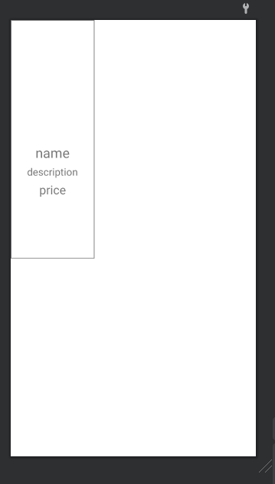

**Grid_row_border.xml**

<?xml version="1.0" encoding="utf-8"?>  
<!--Save this in res/drawable-->  
<shape xmlns:android="http://schemas.android.com/apk/res/android">  
 <solid android:color="@android:color/transparent" />  
 <stroke  
 android:color="@color/material_grey_600"  
 android:width="1dp" />  
</shape>

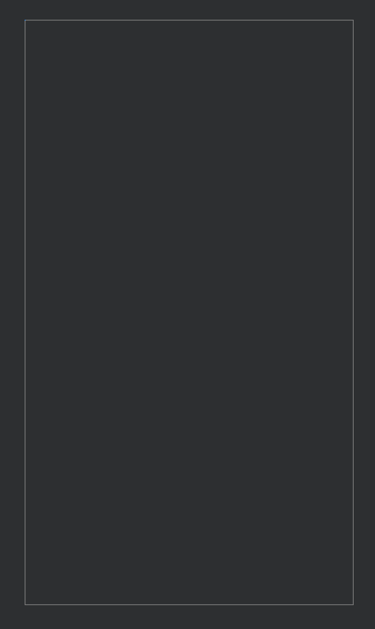

**//Second Page**

**ImageView.java**

package com.example.gridview;  
  
import androidx.appcompat.app.AppCompatActivity;  
import androidx.viewpager.widget.ViewPager;  
  
import android.content.Intent;  
import android.os.Bundle;  
  
public class ImageView extends AppCompatActivity {  
  
 @Override  
 protected void onCreate(Bundle savedInstanceState) {  
 super.onCreate(savedInstanceState);  
 setContentView(R.layout.*activity_image_view*);  
 Intent intent = getIntent();  
 int[] image = intent.getIntArrayExtra("image");  
 ViewPager mViewPager = (ViewPager) findViewById(R.id.*viewPage*);  
 ImageAdapter adapterView = new ImageAdapter(this,image);  
 mViewPager.setAdapter(adapterView);  
 }  
}

**Activity_image_view.xml**

<?xml version="1.0" encoding="utf-8"?>  
<RelativeLayout xmlns:android="http://schemas.android.com/apk/res/android"  
 xmlns:tools="http://schemas.android.com/tools"  
 android:layout_width="match_parent"  
 android:layout_height="match_parent"  
 android:paddingBottom="20dp"  
 android:paddingLeft="20dp"  
 android:paddingRight="20dp"  
 android:paddingTop="20dp"  
 tools:context=".ImageView">  
  
 <androidx.viewpager.widget.ViewPager  
 android:id="@+id/viewPage"  
 android:layout_width="match_parent"  
 android:layout_height="match_parent" />  
  
</RelativeLayout>

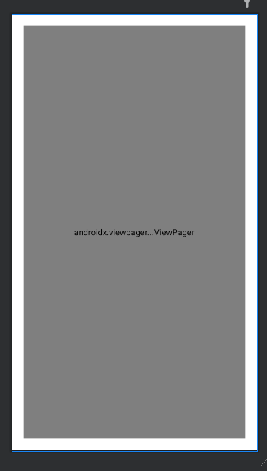

**ImageAdapter.java**

package com.example.gridview;  
  
import android.content.Context;  
import android.view.LayoutInflater;  
import android.view.View;  
import android.view.ViewGroup;  
import android.widget.ImageView;  
import android.widget.LinearLayout;  
import androidx.annotation.NonNull;  
import androidx.viewpager.widget.PagerAdapter;  
import java.util.Objects;  
  
class ImageAdapter extends PagerAdapter {  
  
 // Context object  
 Context context;  
  
 // Array of images  
 int[] images;  
  
 // Layout Inflater  
 LayoutInflater mLayoutInflater;  
  
  
 // Viewpager Constructor  
 public ImageAdapter(Context context, int[] images) {  
 this.context = context;  
 this.images = images;  
 mLayoutInflater = (LayoutInflater) context.getSystemService(Context.*LAYOUT_INFLATER_SERVICE*);  
 }  
  
 @Override  
 public int getCount() {  
 // return the number of images  
 return images.length;  
 }  
  
 @Override  
 public boolean isViewFromObject(@NonNull View view, @NonNull Object object) {  
 return view == ((LinearLayout) object);  
 }  
  
 @NonNull  
 @Override  
 public Object instantiateItem(@NonNull ViewGroup container, final int position) {  
 // inflating the item.xml  
 View itemView = mLayoutInflater.inflate(R.layout.*item*, container, false);  
  
 // referencing the image view from the item.xml file  
 ImageView imageView = (ImageView) itemView.findViewById(R.id.*imageViewMain*);  
  
 // setting the image in the imageView  
 imageView.setImageResource(images[position]);  
  
 // Adding the View  
 Objects.*requireNonNull*(container).addView(itemView);  
  
 return itemView;  
 }  
  
 @Override  
 public void destroyItem(ViewGroup container, int position, Object object) {  
  
 container.removeView((LinearLayout) object);  
 }  
}

**Item.xml**

<?xml version="1.0" encoding="utf-8"?>  
<LinearLayout  
 xmlns:android="http://schemas.android.com/apk/res/android"  
 android:layout_width="match_parent"  
 android:layout_height="match_parent">  
  
 <!-- image viwer to view the images -->  
 <ImageView  
 android:id="@+id/imageViewMain"  
 android:layout_width="match_parent"  
 android:layout_height="match_parent"/>  
  
</LinearLayout>

**Drawable folder**

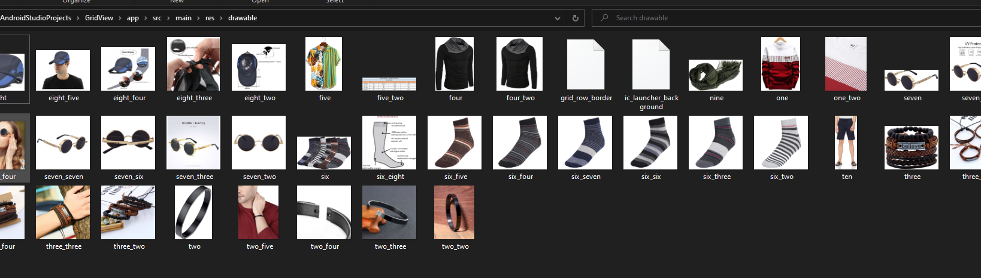

**OUTPUT:**



